# Introduction to Dynamic Programming

## Finding time complexity of a recursive code

**What will be the time complexity of this code ?**

| int f(int x) {  if(x==0)  {  return 2;  }  else  {  return f(x-1) + f(x-1);   } } |
| --- |

Let us take x = 4

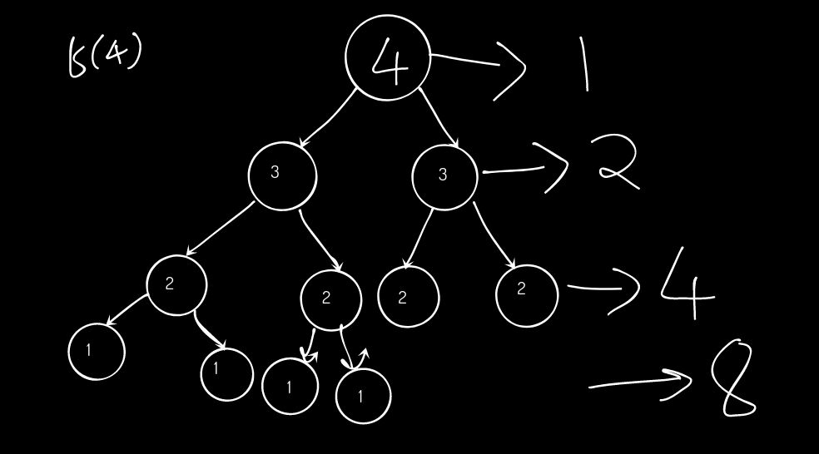

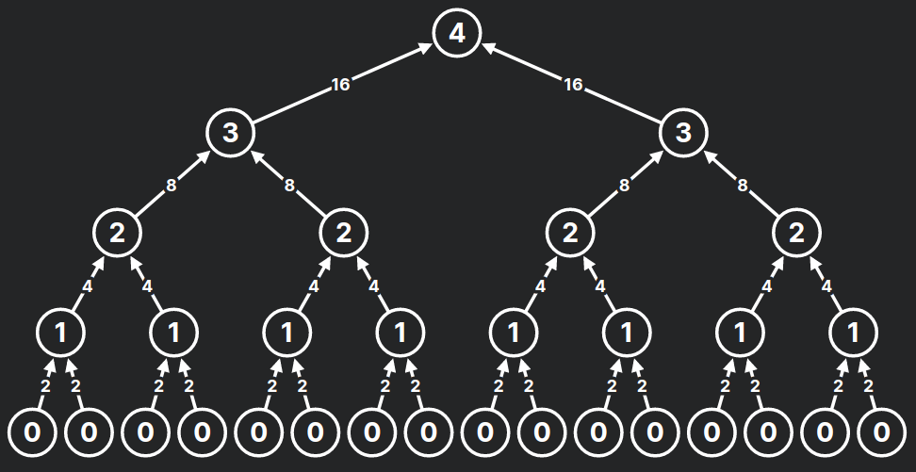

Number of function calls = 1 + 2 + 4 + 8 + 16

= 31

= 25 -1

For if call f(n) , you will get 2(n+1) - 1 function calls

So, the time complexity = O( 2*2n - 1) = O(2n)

Now, let's change 1 line in the code

| int f(int x) {  if(x==0)  {  return 2;  }  else  {  return f(x-1) * 2;   } } |
| --- |

What is the time complexity of this code?

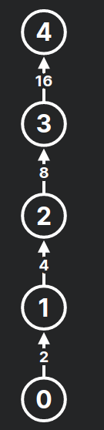

Time complexity = O (n +1 ) = O(n)

You can try this website for visualising the recursion tree:

<https://recursion.now.sh/>

## Intuition of Dynamic Programming

1 + 2 + 6 + 7 + 5 = ?

21

1 + 2 + 6 + 7 + 5 + 2 = ?

21 + 2 = 23

This is DP (Dynamic Programming). **Just remember the past answers and use it to compute your answer.**

**Fibonacci Numbers**

**N :** 1, 2, 3, 4, 5, 6…...

**F(N)** : 0, 1, 1, 2, 3, 5….

**Recurrence relation:**

F(N) = F(N-1) + F(N-2)

**Recursive code for find Nth Fibonacci number (Without DP)**

| int fib( int n) { if(n==1)  return 0; if(n==2)  return 1; return fib(n-1) + fib(n-2); } |
| --- |

Time complexity: O (2 ^n)

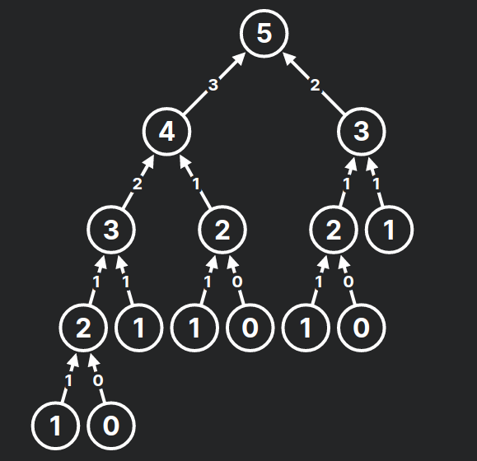

## DP = Recursion + Memoization

| #include <bits/stdc++.h>  using namespace std;  const int MAX = 100000+1;  int dp[MAX]; // dp[i] = i-th fibonacci number  int fib(int n) { if(n==1)  return 0; if(n==2)  return 1; if(dp[n] != -1) {  return dp[n]; } return dp[n]=fib(n-1) + fib(n-2); // Memoization }   int main() {    for(int i=0; i<MAX; i++)  { dp[i]=-1; // no values are computed at the beginning  }  int n;  cin>>n;  cout<<fib(n);  return 0; } |
| --- |

Time complexity: O(n)

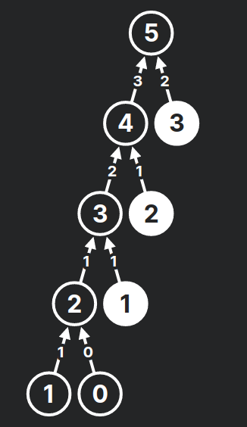

## DP without recursion (iterative DP)

| #include <bits/stdc++.h>  using namespace std;  const int MAX = 100000+1;  int dp[MAX]; // dp[i] = i-th fibonacci number  int main() {    int n;  cin>>n;    dp[1]=0;  dp[2]=1;    for(int i=3; i<=n; i++)  {  dp[i] = dp[i-1] + dp[i-2];   }    cout<<fib(n);  return 0; } |
| --- |

**Time complexity: O(N)**

Wherever we see a recursive solution that has repeated calls for the same inputs, we can optimize it using Dynamic Programming. The idea is to **simply store the results of subproblems**, so that we do not have to re-compute them when needed later. This simple optimization reduces time complexities from exponential to polynomial.

## Bottom Up vs Top Down

### **Bottom Up Approach**:

**Analogy to understand:**

I am going to learn to program. Then, I will start practising. Then, I will participate in coding contests. I will improve by solving those questions which I couldn't solve during every contest. I will be able to crack an internship at a good company.

In Bottom-up you start with the small solutions (base case) and build up.

**Example:** The without-recursion approach (iterative) for finding n-th fibonacci number shown above

**Advantages :**

1. Fast and uses less memory than top down.

2. Shorter Code

### **Top Down Approach:**

**Analogy to understand:**

I will be able to crack an internship at a good company. How? I will improve by solving those questions which I couldn't solve during every contest. How? I will participate in coding contests. How? I will start practicing? I am going to learn to program.

In Top-down you start building the big solution right away by explaining how you build it from smaller solutions.

**Example:** The recursion + memoization approach shown above

**Advantages :**

1. Easy to apply

2. Order doesn't matter.

**Q:** <https://atcoder.jp/contests/dp/tasks/dp_a>

**Recursion Solution:-**

| #include<bits/stdc++.h> using namespace std; vector<int> h; vector<int> Memo;  int minCost(int i){  // It will give me the minimum cost to reach at ith stone  if(i==0) return 0;  if(i==1) return abs(h[1]-h[0]);  if(Memo[i]!=-1) return Memo[i];  int lastCost = minCost(i-1) + abs(h[i]-h[i-1]);  int lastlastCost = minCost(i-2) + abs(h[i]-h[i-2]);  Memo[i]=min(lastCost,lastlastCost);  return Memo[i]; } int main(){  int n;  cin>>n;  h.resize(n);  Memo.resize(n);  for(int i=0;i<n;i++) Memo[i]=-1;  for(int i=0;i<n;i++) cin>>h[i];  cout<<minCost(n-1);  return 0; }  Time Complexity without Memoization = O(2^n)  Time Complexity with Memoization = O(n) |
| --- |

* **H.W- Solve the last problem using iterative DP.**

Q.) You are climbing a staircase. It takes **n steps** to reach the top.

Each time you can either **climb 1 or 2 steps.** In **how many distinct ways** can you climb to the top?

**Iterative Solution:-**

| int climbStairs(int n) {  vector<int> dp(n+1);  //dp[i]-> number of ways to reach at i-th floor   dp[0]=1;  dp[1]=1;  for(int i=2;i<=n;i++) dp[i]=dp[i-1]+dp[i-2];  return dp[n];  } |
| --- |

* **H.W- Solve the last problem using Recursive DP**

**Practice Problems:**

1. <https://atcoder.jp/contests/dp/tasks/dp_b>

2. <https://www.hackerearth.com/practice/algorithms/dynamic-programming/introduction-to-dynamic-programming-1/practice-problems/algorithm/jump-k-forward-250d464b/>

3. <https://atcoder.jp/contests/dp/tasks/dp_c>

4. <https://atcoder.jp/contests/abc129/tasks/abc129_c>

5. <https://codeforces.com/problemset/problem/1245/C>

6. <https://codeforces.com/problemset/problem/455/A%7C>

7. <https://codeforces.com/problemset/problem/1195/C>

8. <https://www.spoj.com/problems/ACODE/>

9. <https://codeforces.com/problemset/problem/189/A>

Just Follow only these websites for practising in first year:

**Codeforces, Atcoder, Codechef, Hackerrank, Hackearth, Spoj**

**On hackerrank, solve all the implementation problems:**

**(Very important for building the basics)**

[**https://www.hackerrank.com/domains/algorithms?filters%5Bsubdomains%5D%5B%5D=implementation**](https://www.hackerrank.com/domains/algorithms?filters%5Bsubdomains%5D%5B%5D=implementation)